HW 7: due 3/04;

Complete the C code (Package) version of Books Collection demo package example. Specifically, you need to provide the implementation for the following global functions in book.c

Book FindBook(int id)

bool DeleteBook(int id)

You can find the code for this package in lecture13_examples.tar.gz tarball which is available on lecture course page here: <https://mwcorley79.github.io/MikeCorley/lecture13/lecture13_examples.tar.gz>.

Note: If you open Firefox from within the Linux Mint VM you can download the tarball directly into the VM. Otherwise you can download the code from your host machine and drag it into a folder in the VM.

Once the lecture13_examples.tar.gz is downloaded to a folder in your VM you can extract the code with the following command: tar xfz lecture13_examples.tar.gz. See screen shot below:

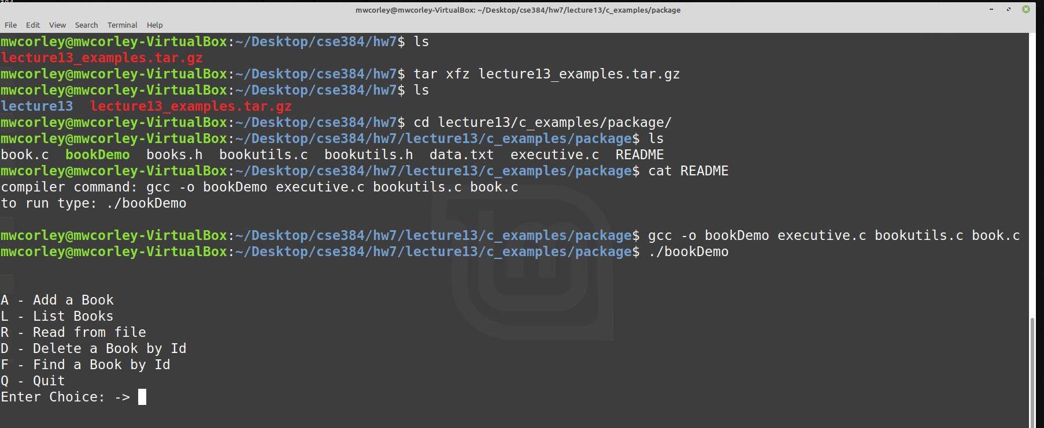

Use nano or vi to open book.c and supply the code for the methods shown

Note: you will need the gcc compiler (or the g++ compiler will work too) Install with the following command: *sudo apt-get install g++*

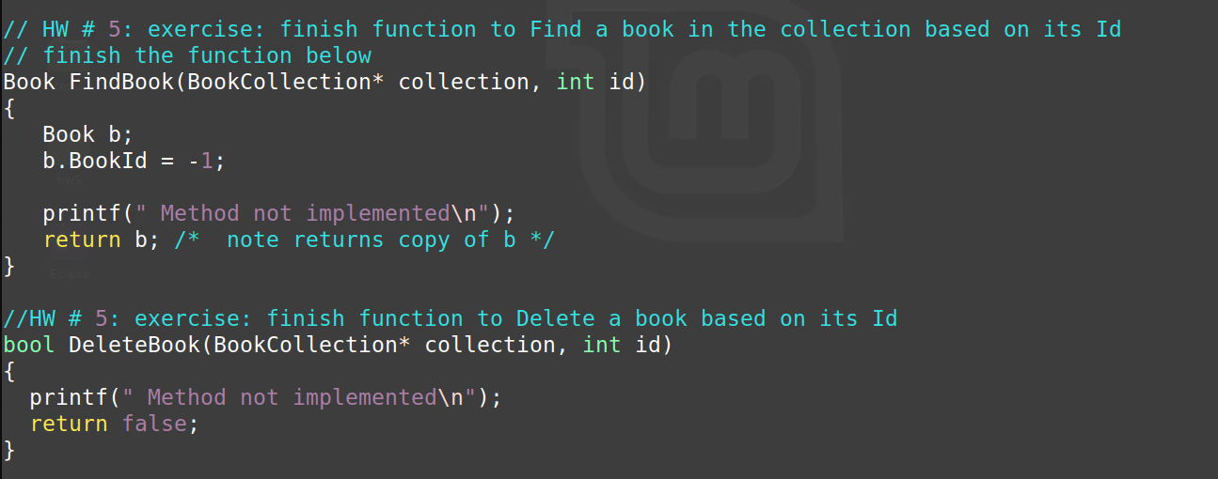

Figure 1: book.c - complete these methods

This is same basic project as completed in HW5 (which was in C++), but this package is done in C. The goal is to allow you to experiment with C and C++, and also see/compare (firsthand) the data management facilities and the conventions used by both. If you completed HW5, then this project should be very easy to complete.

Once complete, please submit your code and output screen shots to Blackboard.